Exponents and Scientific Notation Supplementary Exercises #1 Solutions
Express 140,000,000.00 in scientific notation form.
Solution: 140,000,000.00 is 1.4 x 10⁸.
- Express 0.000487 in scientific notation form.
Solution: 0.000487 is equal to 4.87 x 10⁻⁴.
- What is the value of 9.2 x 10⁰?
Solution: 9.2 x 10⁰ equals 9.2, since 10⁰ = 1, as shown in Zero Rule #1.
- Multiply 3.8 x 10⁴ by 4.2 x 10².
Solution: The rule for multiplying numbers in scientific notation form requires that the numbers themselves are multiplied, but the exponents are added. Thus,
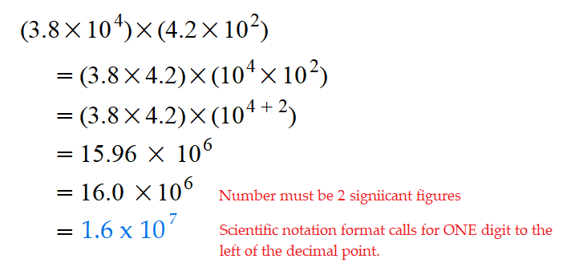

- What is 5.1 x 10² squared?
Solution:
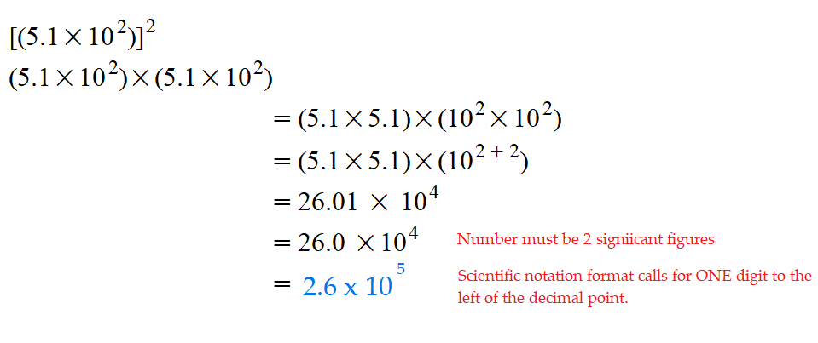
- What is [3.25 x 10²]³?
Solution:
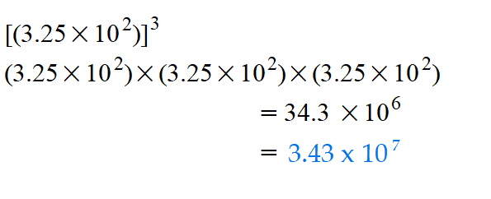
- Divide 8.1 x 10² by 5.4 x 10¹.
Solution:
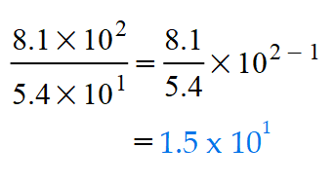

- Divide 4.2 x 10⁻² by 9.86 x 10⁻³.
Solution:
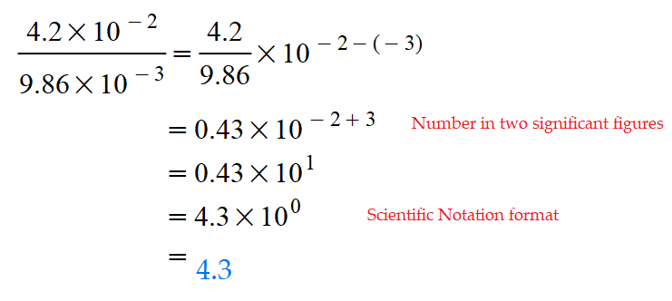
- Add 6.2 x 10² to 9.1 x 10³.
Solution:
When performing addition with numbers in given in scientific notation, it is best to convert the numbers to their nonscientific form, perform the addition, then convert the answer back to scientific notation.
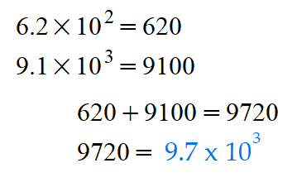

- What is (9.3 x 10³) – (8.0 x 10²)?
Solution:
