Math for Nurses Module 2

Activity 1
Student Learning outcome: Use fractions, perform multiplication and division of fractions, and calculate speed from a graph.
In this activity, you will use fractions and operations of fractions to find the speed of several subway cars using a graph.
Step 1. Review
Review the learning resources for this lesson before studying the case problem.

Step 2. Analyze
Analyze the case problem below.

The graph shows the speeds of three subway cars represented by the colored dots on the graph. Find the speeds of each of the cars by using the rate:
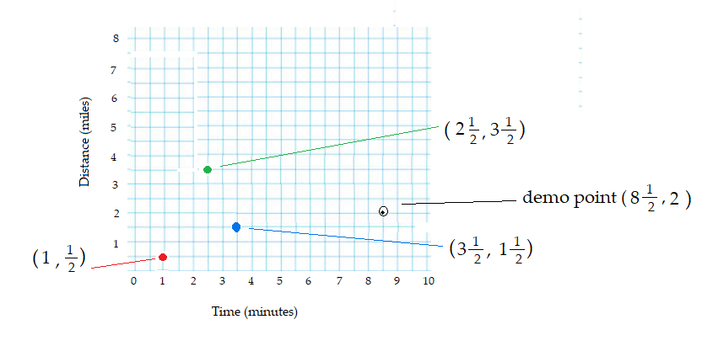
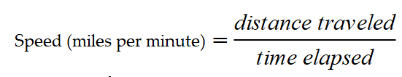

Let us use the demo point on the graph to find the speed,
The point is
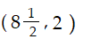.

That is, eight and a half minutes minutes and 2 miles.
Speed is distance (miles) divided by time(minutes).
Thus, the speed of this demo car is:

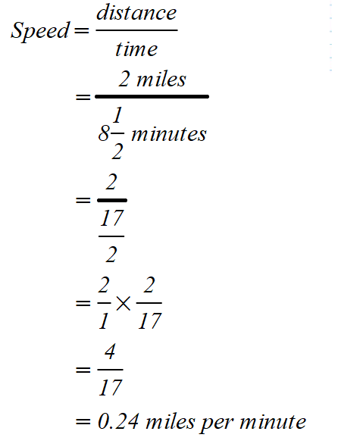

Thus, the speed of the demo car is 0.24 miles/minute.

Using this method, find the speeds of the 3 subway cars shown on the graph as the red, the blue and the green dots.

