Math for Nurses Module 3

Activity 1
Student Learning outcomes:
- Convert three metric quantities to a larger or smaller quantity.
- Convert three metric quantities to the US Standard equivalents.
- Convert three US Standard units to the metric equivalents.
- Use fractions and decimals with operations on fractions and decimals in the conversions above.
- Read and understand word instructions that deal with a likely unfamiliar topic.
This activity provides process, examples, and practice for converting units of weights and measures. You will practice converting metric units to larger and smaller quantities and converting between metric and US units. Solving and conversions will involve three instances of units and unit conversions with MEMS applications. MEMS stands for Micro-Electro-Mechanical Systems. It's a technology that integrates mechanical and electronic components on a microscopic scale, creating devices that can sense, actuate, and process information. MEMS devices are used extensively in medical machines and instruments.
- Conversion from an electron microscope
- Conversion with density and mass of a gold bar used in circuit fabrication.
- Conversion with MEMS thin films.

Step 1. Review
Review the learning resources for this lesson before studying the case problem.

Step 2. Analyze
Analyze the three case problems below and make the conversions.

- A particular MEMS device that is used in medical CAT scan machines, includes a thin spring. It is very important for the spring to have a consistent width from device to device. If the spring is too wide, it will be too stiff, and if it is too narrow, it will be too compliant. Below is an image from a scanning electron microscope (SEM) of a MEMS comb drive and its spring (in the center).
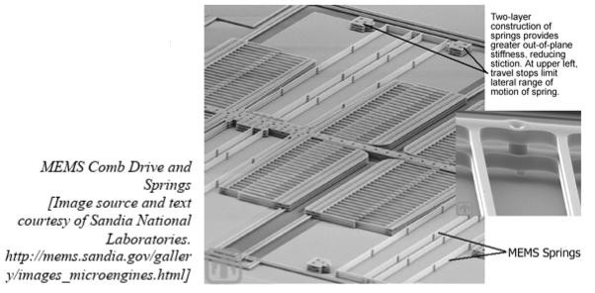
You are a technician that works with a scanning electron microscope which measures in nanometers. The spring you are testing measures 610 nm in width. According to the manual, to pass the test, the spring must measure between 0.48 and 0.62 micrometers in width. Does this spring pass the test?

- The MRI Scan machine uses a device that contain coatings called thin films. A repair technician set up a process to coat the device with a thickness of anywhere from 40 to 60 angstroms (Å). However, the tool the technician is using is set up to measure in nanometers. What is the measurement of this thin film in nanometers? (IÅ = 0.1 nanometers).

- Density is a physical property of matter that describes the degree of compactness of a substance. The more closely packed together the individual particles of a substance, the higher the density of that substance. Density is given as the ratio between the mass and volume of a substance, or,
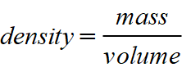
Mass is the amount of matter contained in an object. Mass (m) is usually measured in units of grams (g). Volume (v) is the amount of space occupied by a quantity of matter. Volume is expressed in cubic centimeters (cm³).
Gold is a commonly used element in MEMS fabrication. It is used as a conducive layer, a reflective layer and a bonding layer (see graphic below).
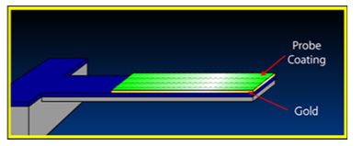
The density of gold is 19.3 g/cm³. So, we ae going to make a comparison of two gold objects. We will compare the mass of a gold bar to that of a gold MEMS layer.
A gold bar, such as the one stored in the Federal Reserve measures
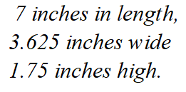
- What is the mass (in pounds) of this gold bar?
- Find the mass in pounds of a layer of MEMS gold that measures:
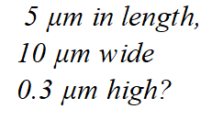
Tables
The tables below can be used for this activity.
- Metric Prefixes.
- Metric to US Standard equivalents
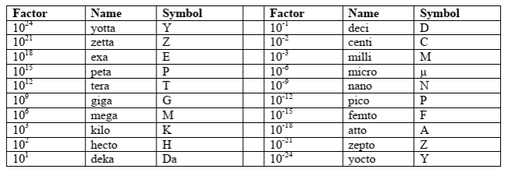
Table 1: Metric Prefixes

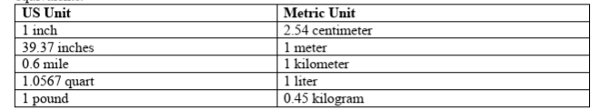
Table 2: Metric and US Standard Equivalents

Step 3. Respond
Respond to the case problem by showing all the steps you take to solve this problem.

