Ratios, Rates, and Proportions
Supplementary Exercises #1 Solutions

Write each of the following ratios in its simplest form.
- 7 : 14
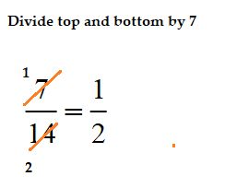 1 : 2
- 15 : 25
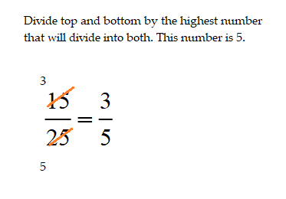 3 : 5
- 4 : 10 2 : 5
- 15 : 60 1 : 4
- 14 : 21 2 : 3
Write each of the following ratios in the form of 1 : n.
- 3 : 12
We want the ratios 3:12 be in the form of 1 : n, so we can expess the equality as a proportion.
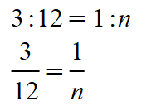
No we can cross multiply to solve for n.
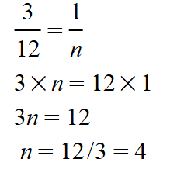
Thus, n = n and the ratio 3 : 12 can be expressed as 1 : 4.
- 5 : 6
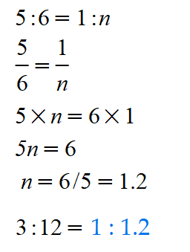
- 10 : 42
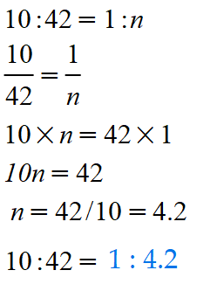

- 15 : 12
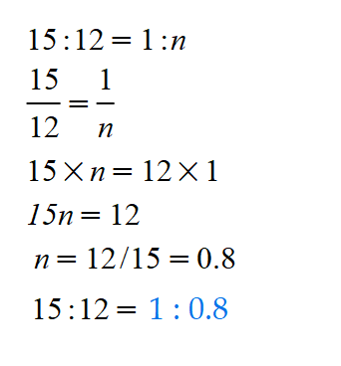
- 8 : 20
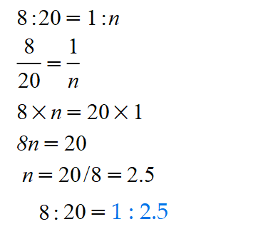
Solve the following ratio problems.
- The scale on the map is 1 : 5,000. What actual distance does a distance of 15 cm on the map represent?
Solution:
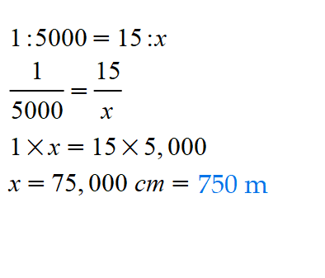

- In a school there are 850 students to 40 teachers. Write the ratio of teachers to students.
Solution:
The teacher to student ratio is 40 : 850. We need to express this as 1 teacher to x students. We use a proportion.
40 : 840 = 1 : x
