Ratios, Rates, and Proportions
Supplementary Exercises #2 Solutions

Ratio and proportion are used in many different situations. Solve the following siuational problems in ratio and proportion:
- A beaker contains 300 ml of a mixture. The mixture is made by mixing 50 ml of concenrate with distilled water. Find the ratio of concentrate to water.
Solution:
Amount of water: total mixture – ml of concentrate = 300 – 50
= 250 ml water.
The ratio of concentrate to water is 50 : 250.
This simplifies to 1 : 5.
Thus, the ratio of concentrate to water is 1 : 5.

- The ratio of blue M&Ms to other colored M&Ms in a packet is 1 : 12. How many total M&Ms would there be in the packet if it contained 5 blue M&Ms and kept the same ratio?
Solution:
A ratio of 1 to 12 means that for every blue M&M there are 12 M&Ms of other colors.
If the packet contains 5 blue M&Ms then it will contain 5 x 12 = 60 M&Ms of other colors to give a otal of 65 M&Ms in the packet.

- A cashier in a bank was givien one million dimes (10-cent coin) to count. How long will it take the cashier to count the coins if he or she can count five dimes in one second?
Solution:
We can set up the proportion:
5 dimes in 1 second = 1 million dimes in X seconds. Now we need to find X.
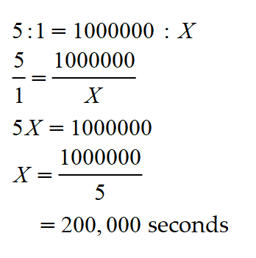
Now we convert seconds to hours. There are 3,600 seconds in 1 hour. Therefore, to find the number of hours in 200,000 seconds, simply divide 200,000 by 3,600.
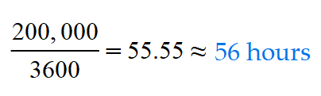
- The potassium chloride in the lab is made by diluting the concentrated substance with water in the ratio of 1 : 8. That is, 1 part of concentrated KCl with 8 parts of water. How much water is to be mixed with 20 ml of KCl?
Solution:
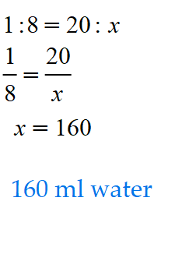
- Three men are digging trenches to install cables to connect new homes to the electricity supply. Working together they can dig 12 m of trench each day. If one of the men hs to stay at home ill for several days, how long will it take the remaining 2 men to dig 120 m of trench?
Solution:
If three men can dig 12 m in one day, then 1 man can dig 4 m in one day, and two men can dig 8 m in one day. Thus, the time taken to dig 120 m is calculated from the proportion
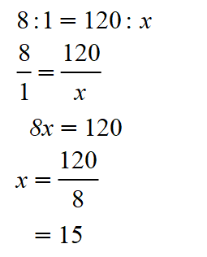
Thus, to dig 120 m, the two men will take 15 days.

