Unit Conversion Supplementary Exercises #1 Solutions

- Convert 4.352 micrograms to megagrams.
Solution:
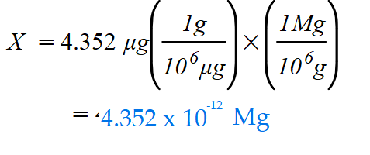

- The volume of the earth’s oceans is estimated to be 1.5 x 10¹⁸ kiloliters (kL). What is this volume in gallons? 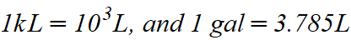
Solution:
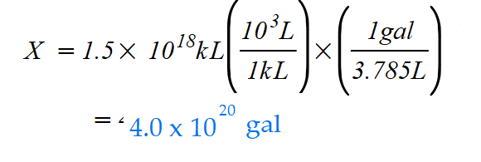

- The mass of the ocean is about 1.8 x 10²¹ kg. If the ocean contains 0.014% by mass hydrogen carbonate ions, HCO3–, how many pounds of HCO3– are in the ocean?
(1 kg = 2.205 pounds)
Solution:
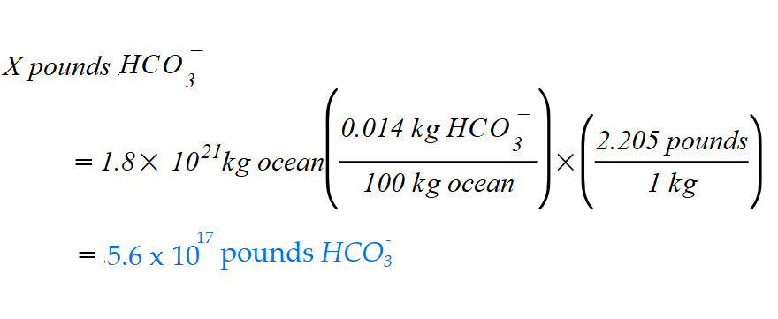

- When you are doing heavy work, your muscles get about 75 to 80% by volume of your blood. If your body contains 5.2 liters of blood, how many liters of blood are in your muscles when you are working hard enough to send them 78% by volume of your blood?
Solution:
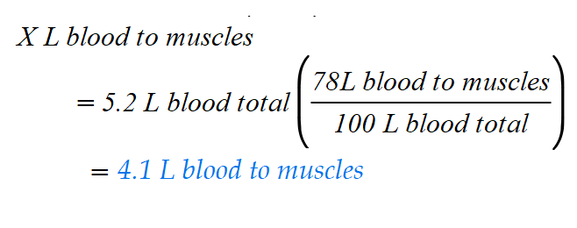

- There are 4.070 x 10⁶ lbs. of sulfuric acid used to make Jell-O each year. Convert this to kilograms. (453.6 g = 1 lb.)
Solution:
