Dividing Mixed Numbers Worksheet

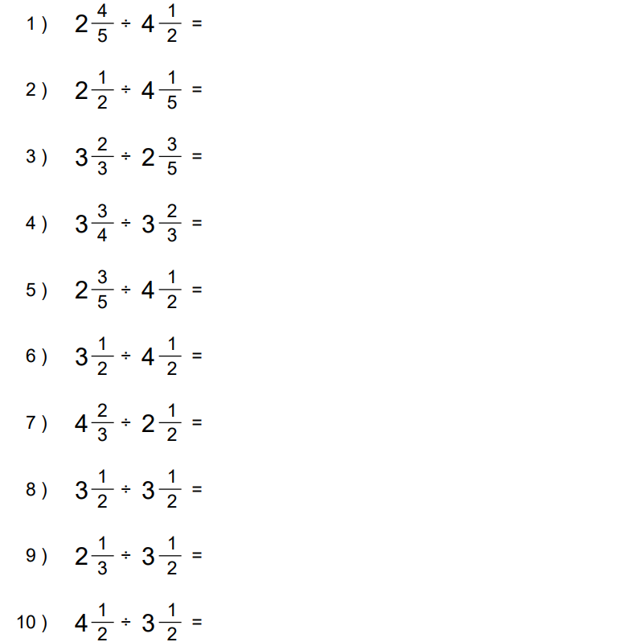

Dividing Mixed Numbers Worksheet: Answers

