Dividing Fractions and Whole Numbers Worksheet

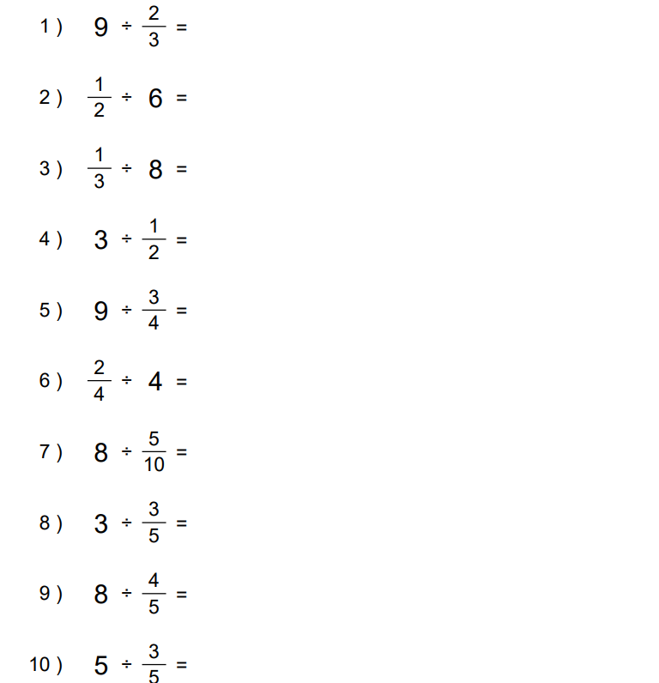

Dividing Fractions and Whole Numbers Worksheet: Answers

