Subtracting Simple Fractions Worksheet

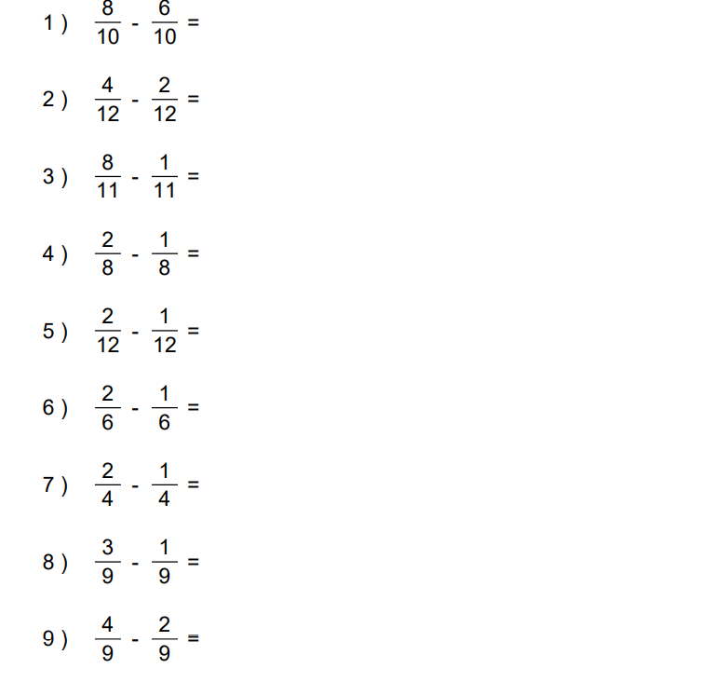

Subtracting Simple Fractions Worksheet: Answers

