Adding Two General Fractions Worksheet

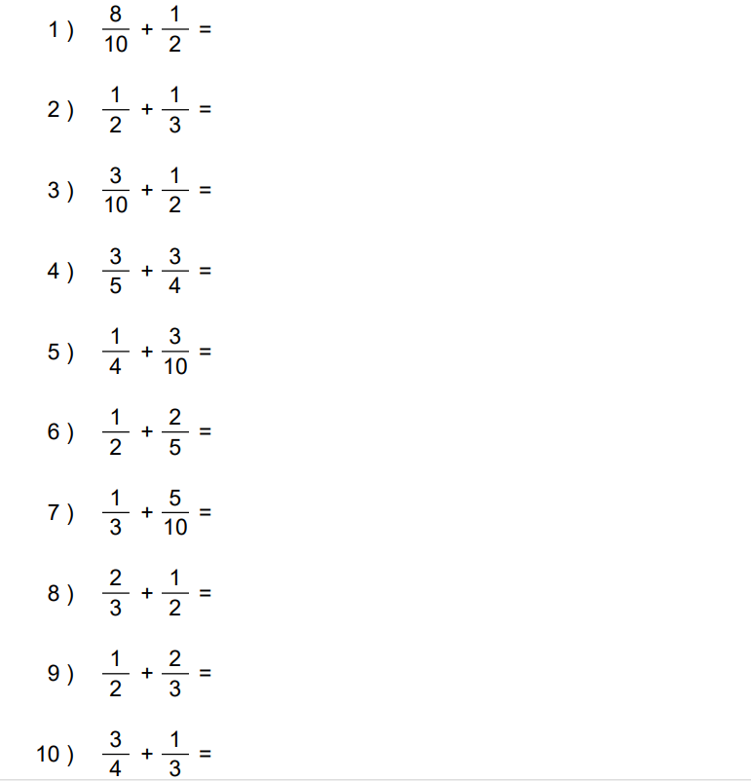

Adding Two General Fractions Worksheet: Answers

