Dilutions Calculation Worksheet #1

To solve the following problems, use the formula
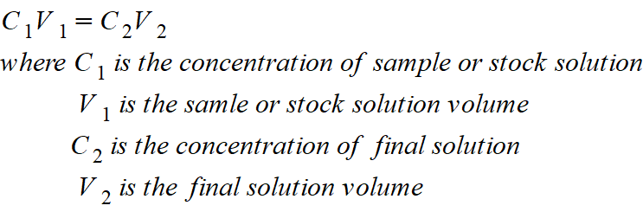

1. How much of a 4 mg/mL stock solution of amylose-azure will be needed to make 5 mL of a 0.5 mg/mL final solution?

2. What is the concentration of the final solution if 4 L of a 50 mg/L stock are used to create 120 L of the final solution?

3. If you begin with 50 mL of a 0.20 M NaCl solution and dilute it to 1,000 mL, what is the concentration of the final solution?

4. How much of an 8.0 M HCl solution should be used to make 500 mL of a 0.050 M final solution?
.
5. If you begin with 250 mL of NaCl solution with a concentration of 4 g/mL, what will the concentration of the final solution be if you add 70 mL of water?

6. How much of a 0.2 M glucose solution can be made from 50 mL of a 0.50 M stock glucose solution?

7. If 15 mL of a sample was added to 90 mL of diluent, what is the ratio and what is the dilution?

