Molality Calculation Worksheet #1: Solutions (Answers)

- Determine the molality of a solution prepared by dissolving 28.60g of glucose (C6H12O6) into 250g of water.
Solution:
The Molality formula is:
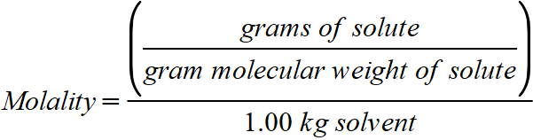
Thus, substituting and solving:
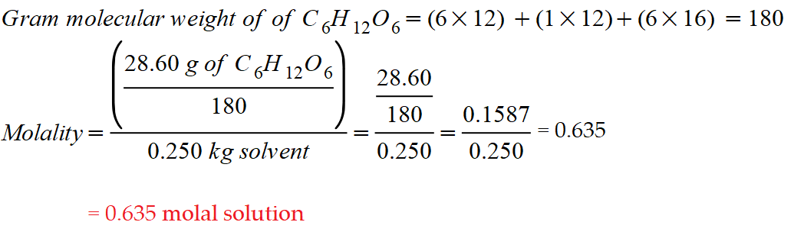

- Calculate the molality of a solution where 5 grams of toluene (C₇H₈) is dissolved in 225 grams of Benzene (C₆H₆).
Solution:
The Molality formula is:
Thus, substituting and solving:
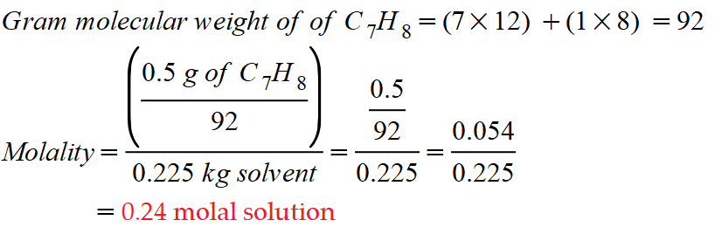

- How many grams of KCl are necessary to make a 1.24 molal solution?
Solution:
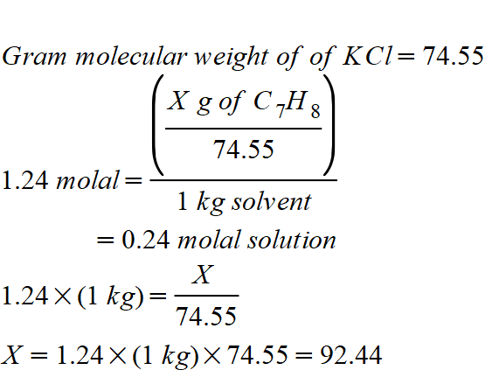
Therefore,
92.44 grams of KCl are needed to prepare a 1.24 molal solution.

