Molarity Calculation Worksheet #2: Solutions

- What is the molarity of a solution that contains 2.30 mol of hydrochloric acid in 1.00 L of solution?
Solution (how the problem was solved, not a chemical solution):
To solve this problem, we use the formula for molarity. By substituting the numbers into the formula, the following equation arises:
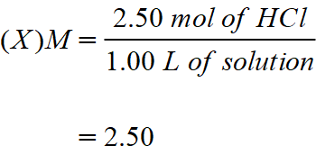
Therefore, this solution has a concentration of 2.50 M, or the solution has a molarity of 2.50.

- If you wanted to make 1.00 L of a 0.200 M solution of Na₃PO₄, how many grams of Na₃PO₄ would you need?
Solution:
The first step is to list the gram atomic weight of each individual element in the compound, then add them together to get the gram molecular weight of the compound.
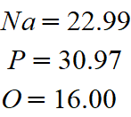
The gram molecular weight of the Na₃PO₄ is 163.94. By substituting the quantities that are known into the molarity formula, we solve for grams needed:
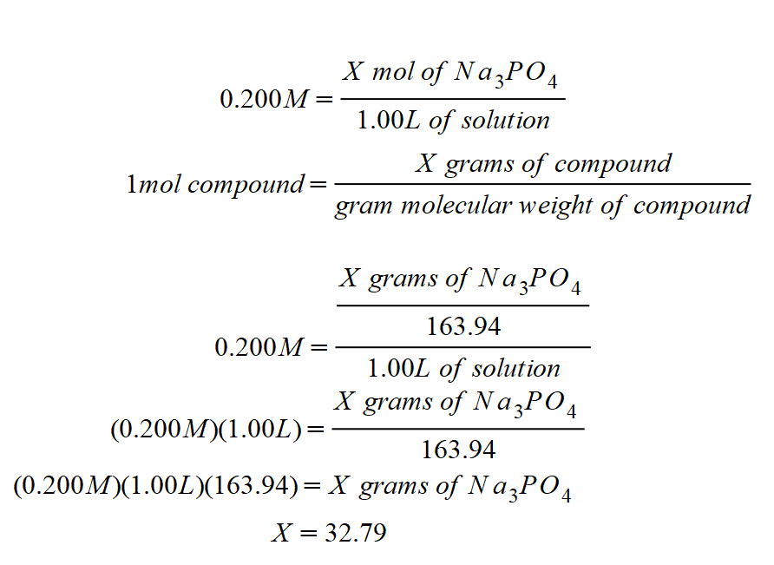
Therefore, to prepare the above solution, we will need 32.79 grams of Na₃PO₄.

- Using You weigh out 40.0 g of KCl and dissolve them into 500 mL of water. What is the molarity of the solution that you just made?
Solution:
Using the molarity formula, the following equation arises:
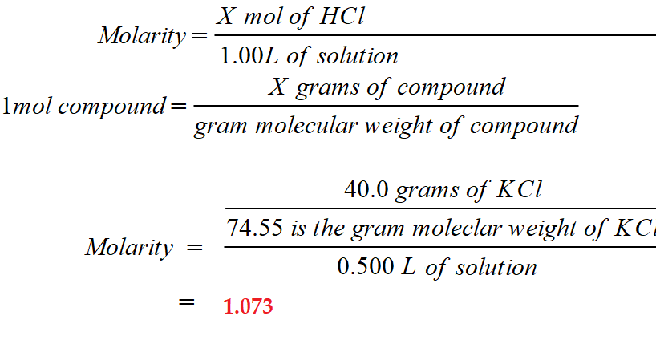

- Using A solution contains 2.75 g of HCl in 1 L of solution. What is the millimolar concentration of this solution?
Solution:
To solve his problem using the millimolar formula, we first convert the grams to milli grams by multiplying the number of grams by 1000.
2.75 g of HCl = 2,750 milligrams of HCl.
Now use the formula:
