Molarity Calculation Worksheet #1: Solutions
- The gram molecular weight is the sum of the atomic weights of K and Cl. The gram atomic weight of potassium (K) is 39.10 and the gram atomic weight of chlorine is 35.45. Therefore, the gram molecular weight of KCl is
39.10 + 35.45 = 74.55.
- The gram molecular weight of sodium hydroxide(NaOH) is the sum of the gram atomic weights of sodium (Na), hydrogen (H), and oxygen(O). Therefore, the gram molecular weight of NaOH is
22.99 (Na) + 16.00 (O) + 1.01 (H) = 40.00.
- The gram molecular weight of HCl is 36.46. Using the formula for moles, the number of grams of HCl in 1 mol can e determined:
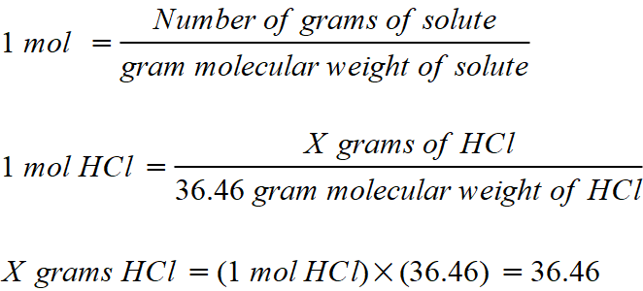
Therefore, there are 36.46 grams of HCl in 1 mol.

- The gram molecular weight of H₃PO₄ is the sum of the atomic weights of the hydrogen, the phosphorus, and the oxygen. There are three hydrogen atoms and four oxygen in this molecule. Therefore, the gram molecular weight of H₃PO₄ is:
  - x 3) + 30.97 + (16.0 x 4) = 98.00.

- The gram molecular weight of CaCl₂ is he sum of the atomic weights of the one calcium and the two chlorine atoms:
40.08 + (35.45 x 2) = 110.98.

